Task 1 :Database Setup and Schema Design.

Using Phpmyadmin And sql server

1.Database creation

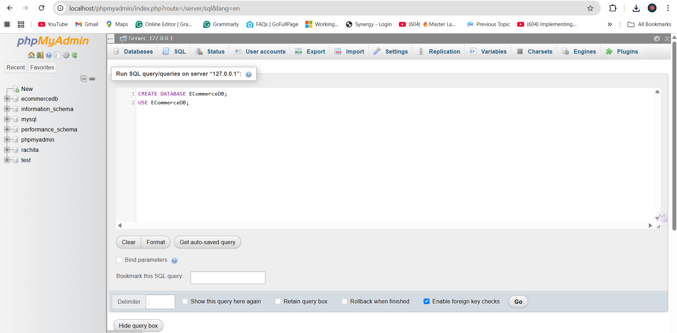

Table Creation

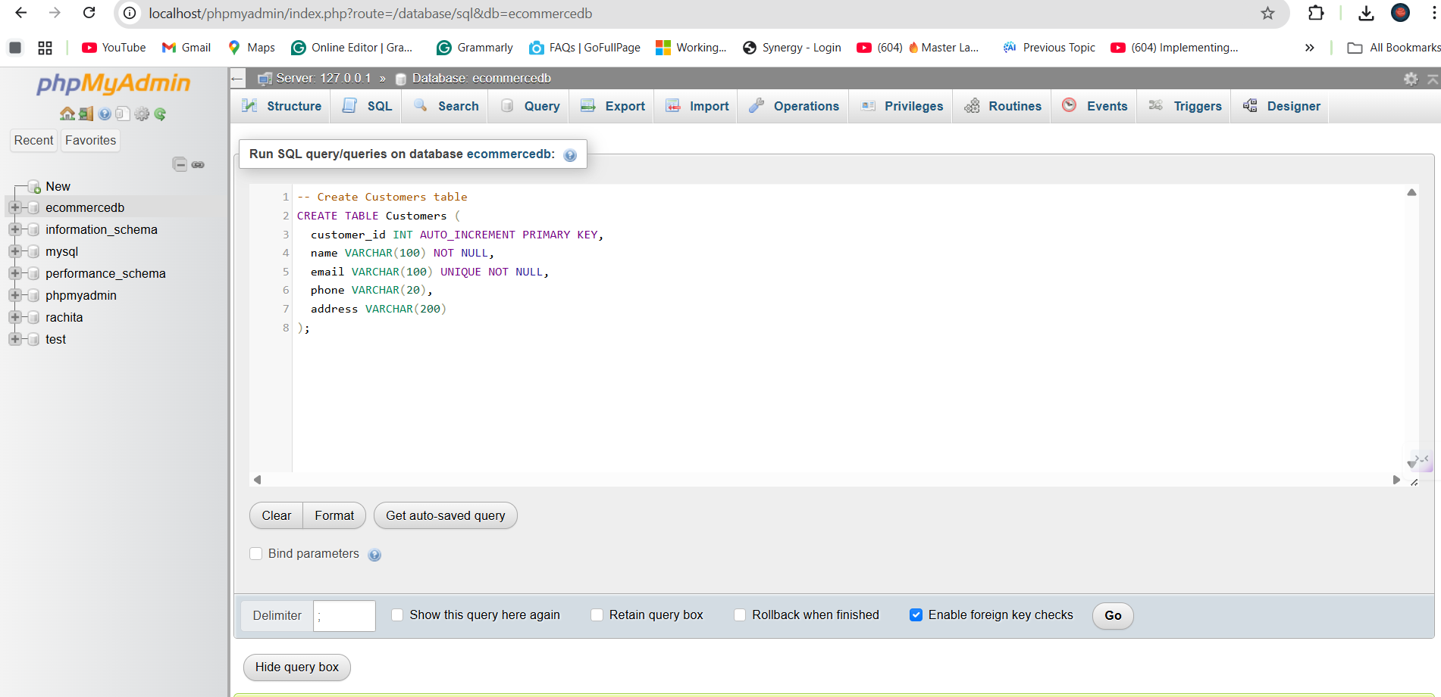

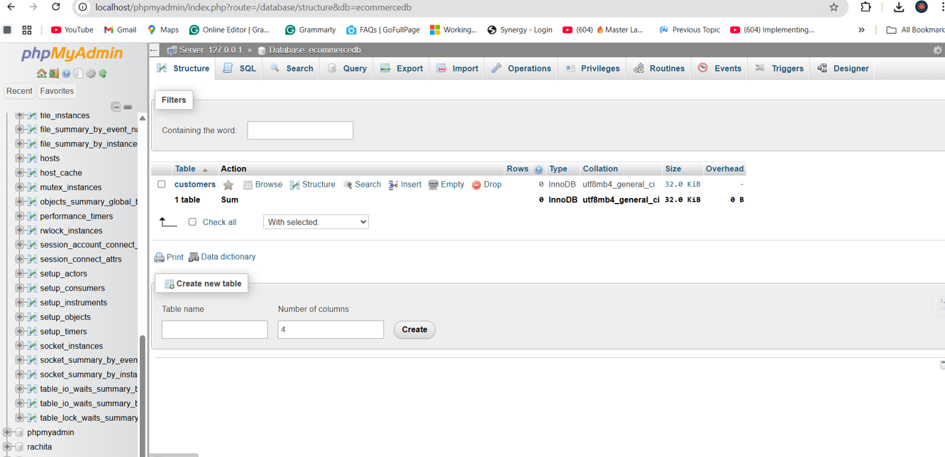

Primary Key and Foreign key under Customer Table

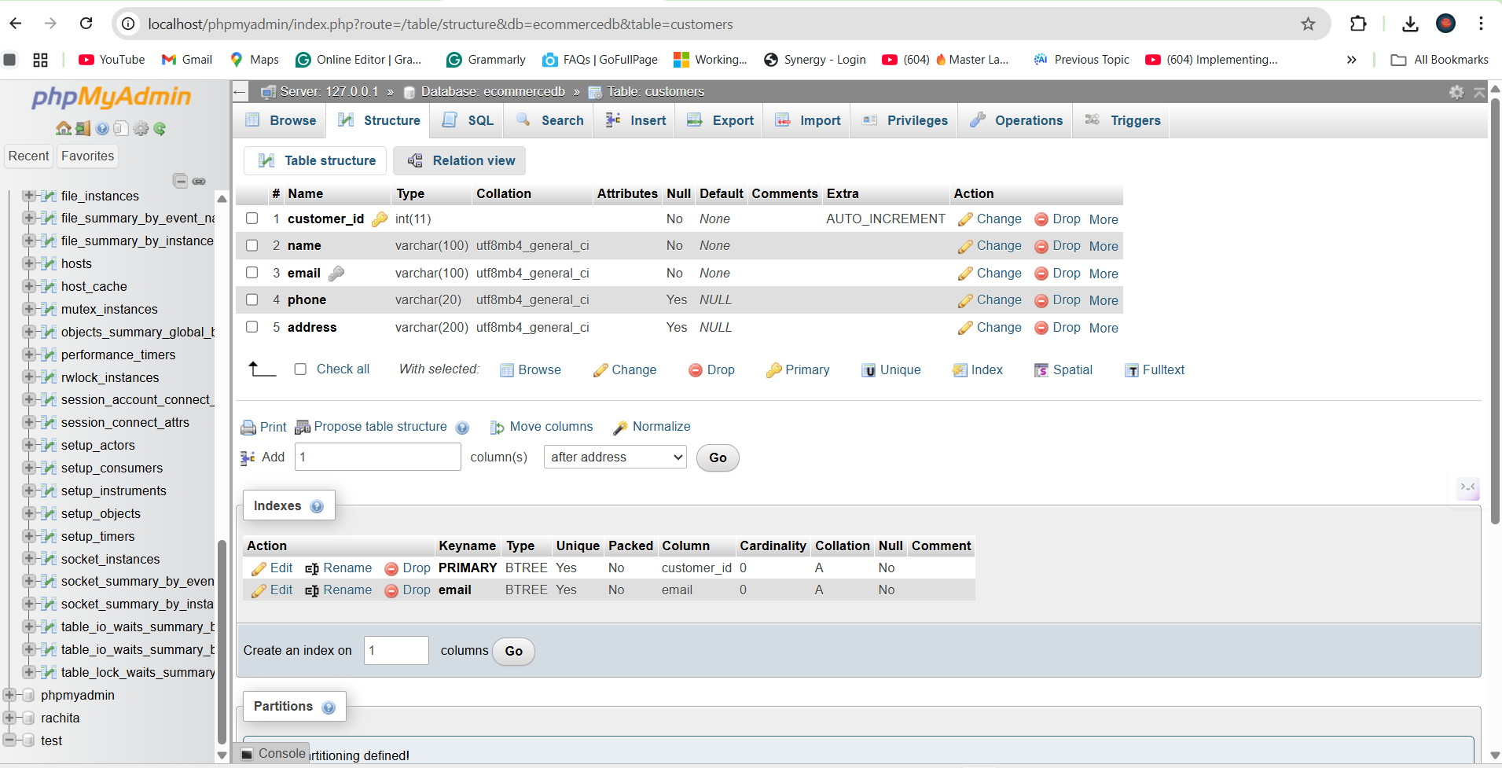

Product Table

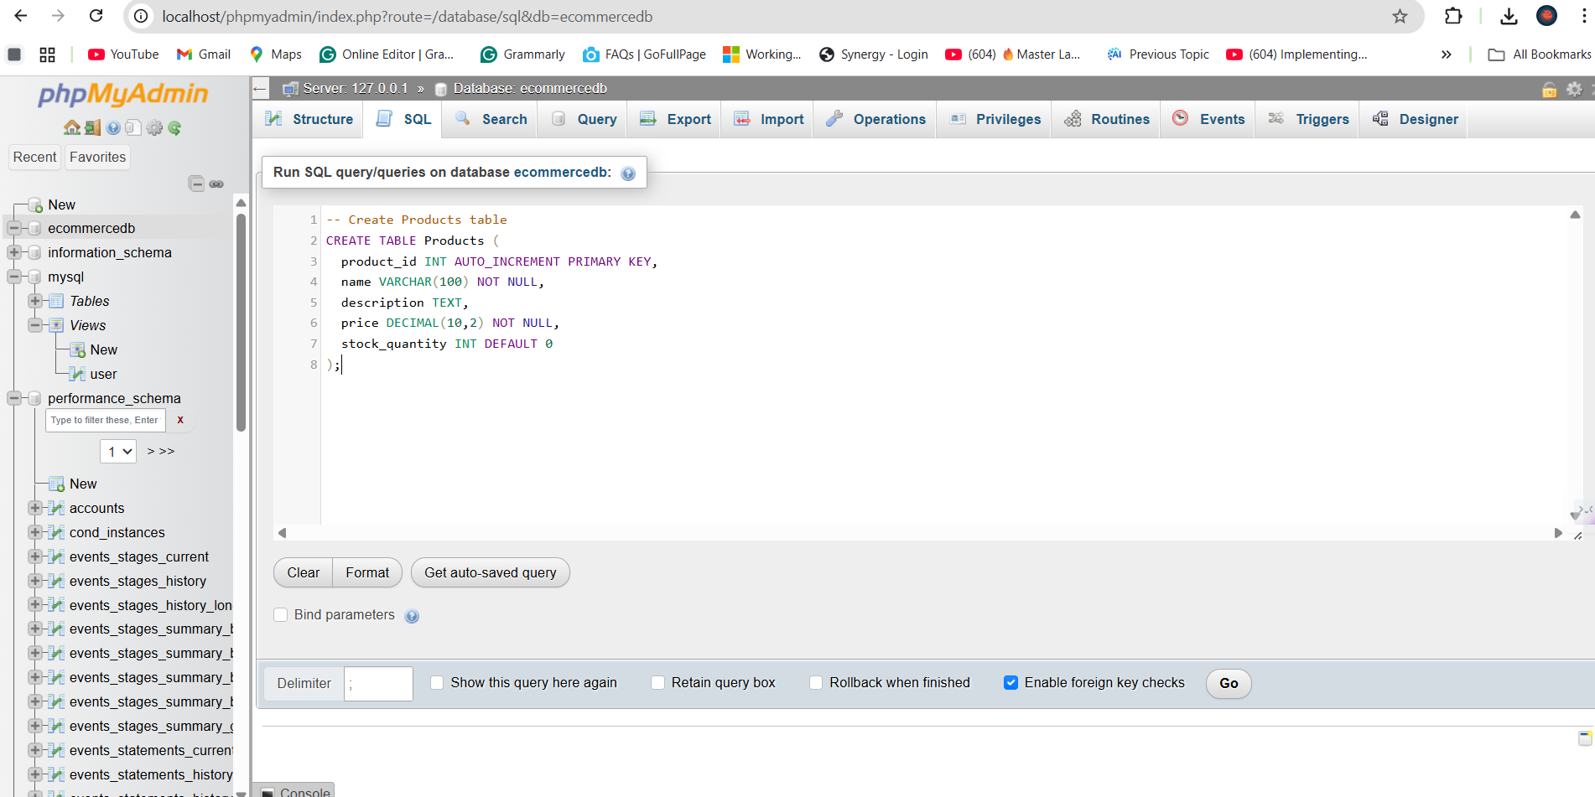

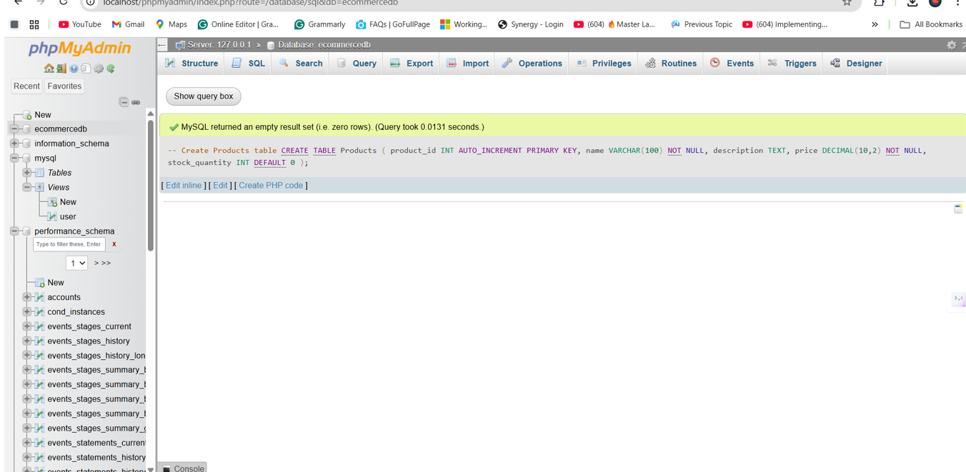

Primary Key under product table

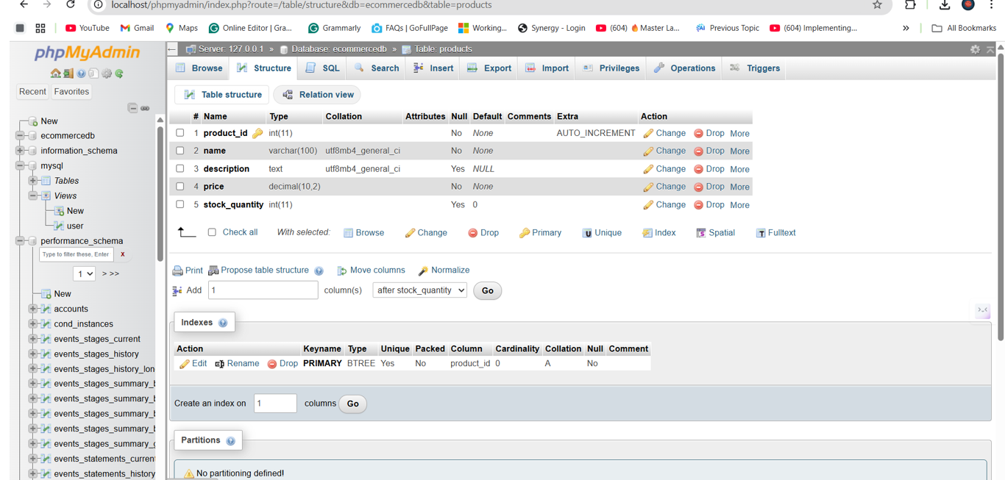

Both Tables screen shot

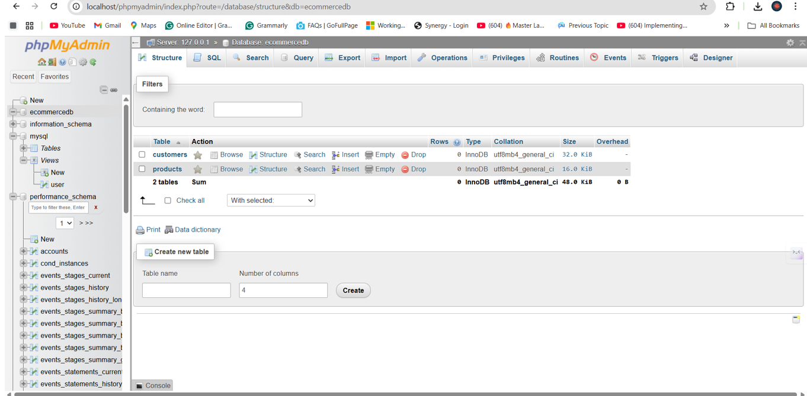

Order Table

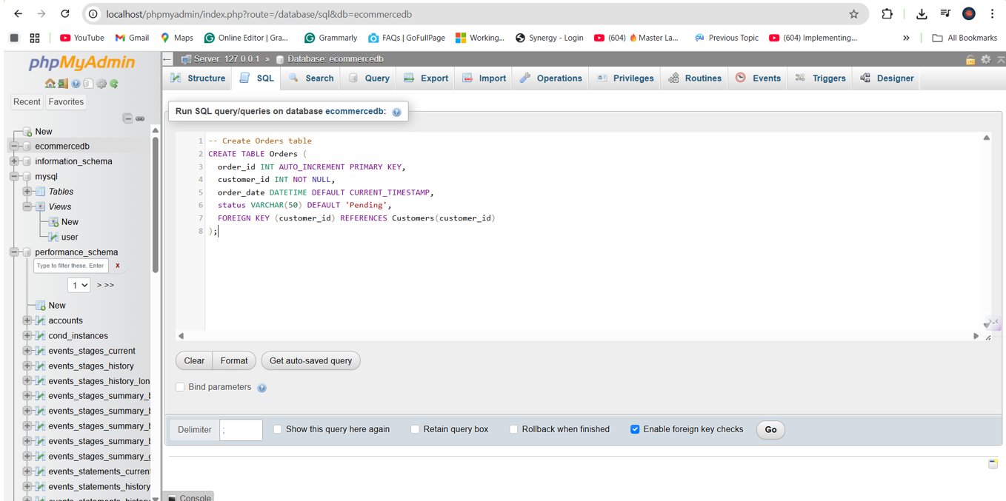

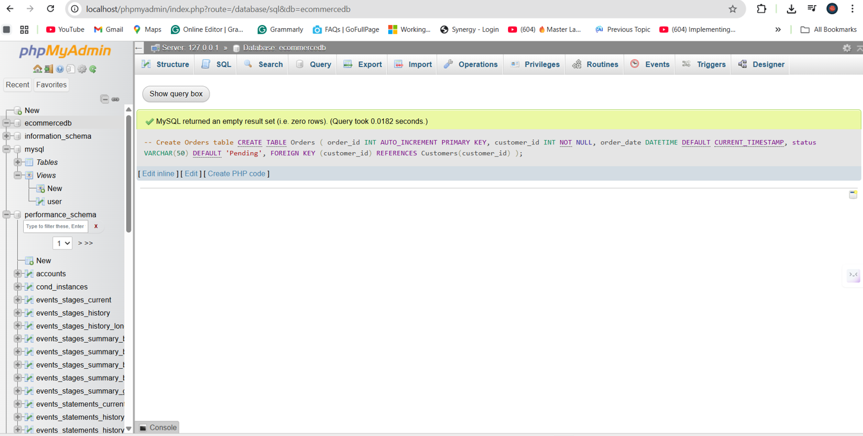

Primary Key and Foreign under Order table

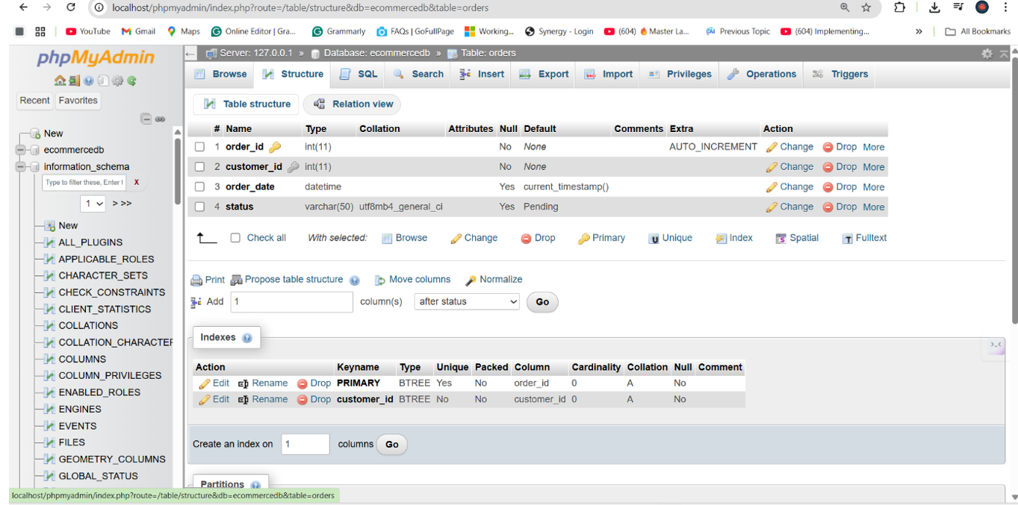

Order Item Table

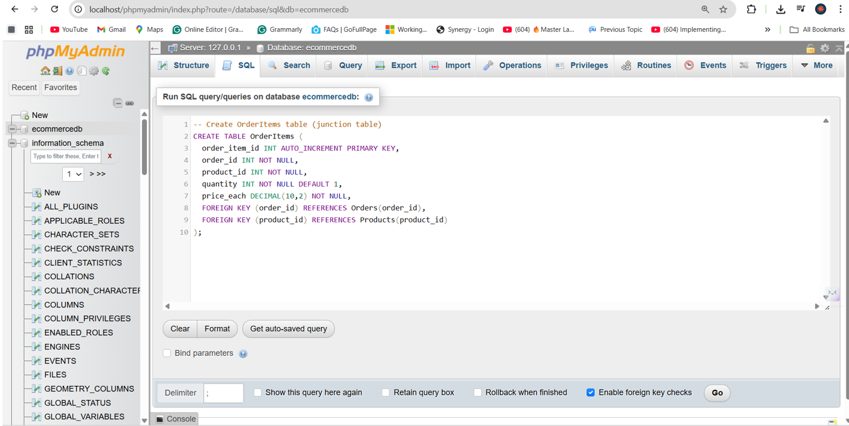

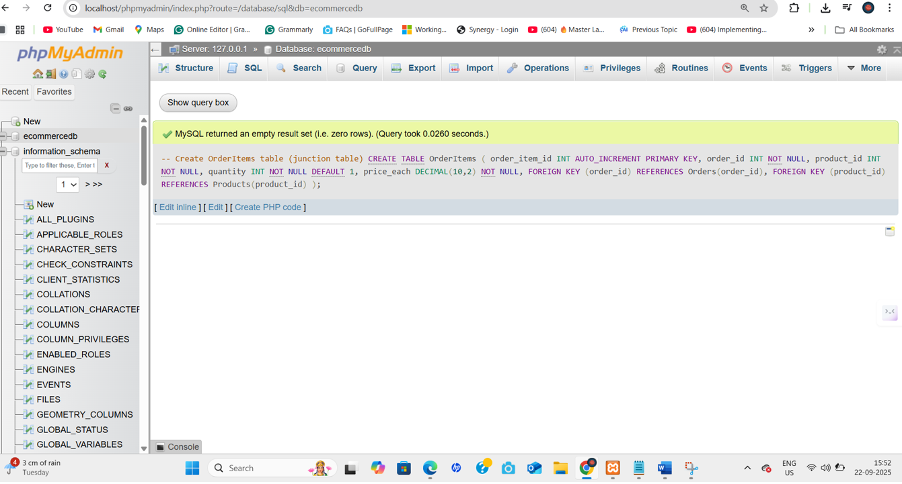

Primary Key And Foreign key under order item table

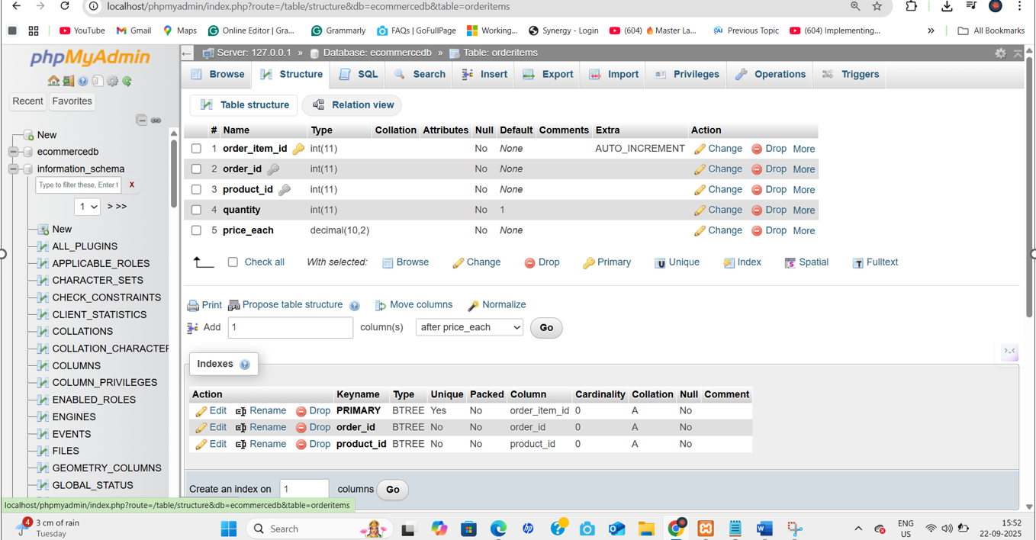

Payment Table

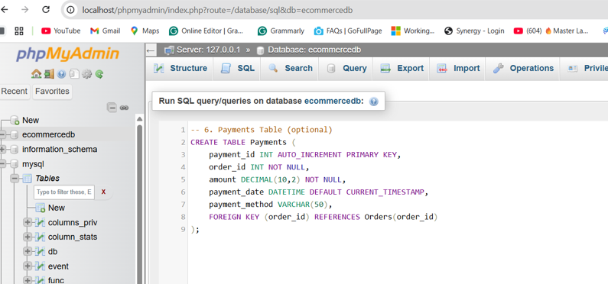

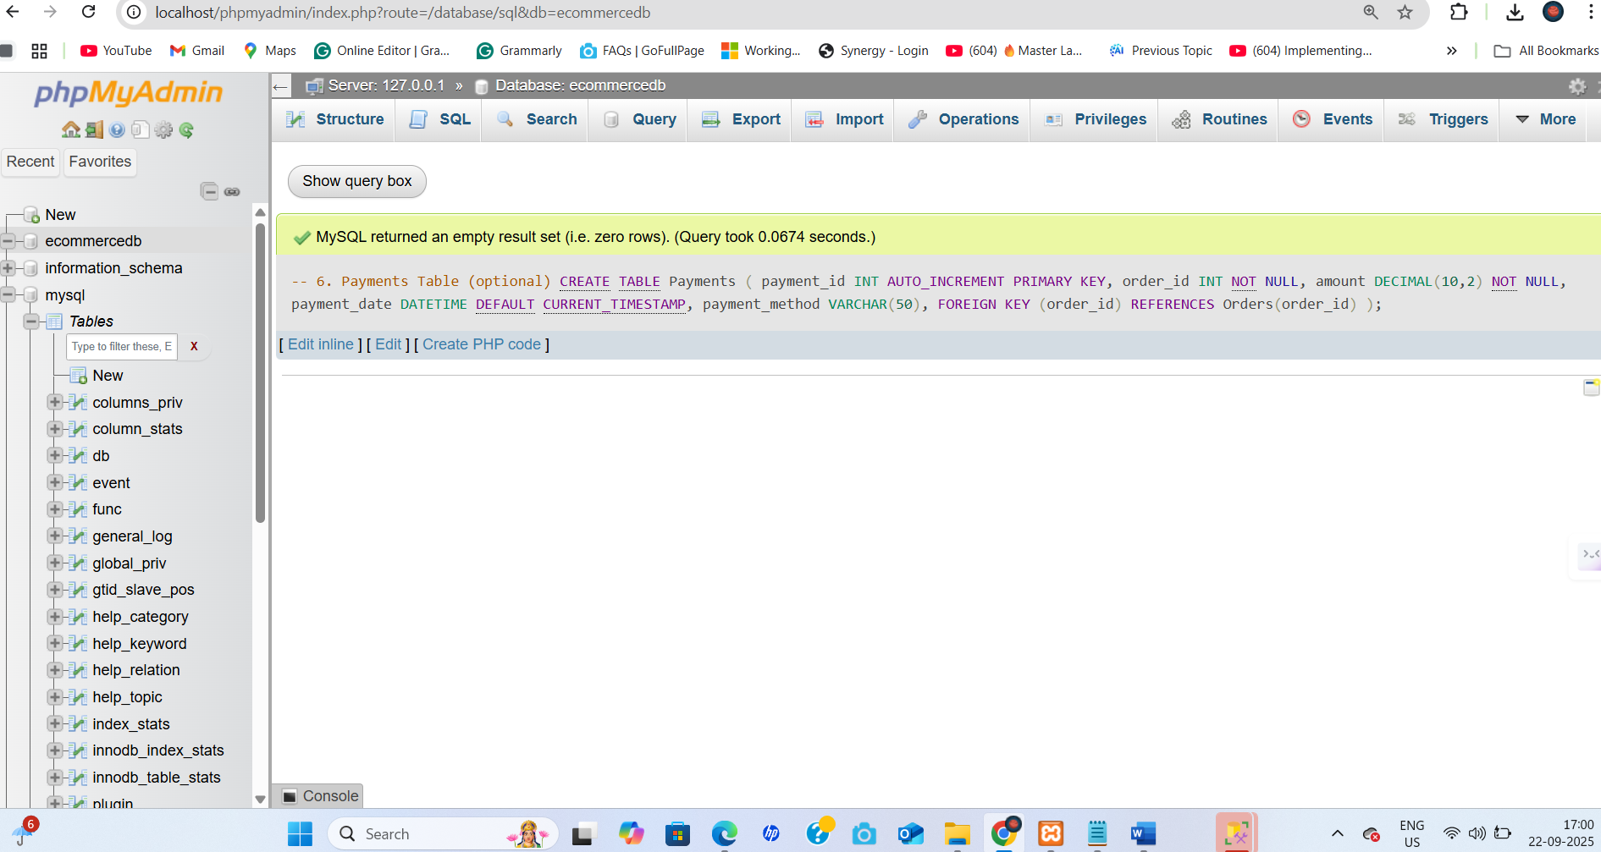

Primary key and foreign key under payment table

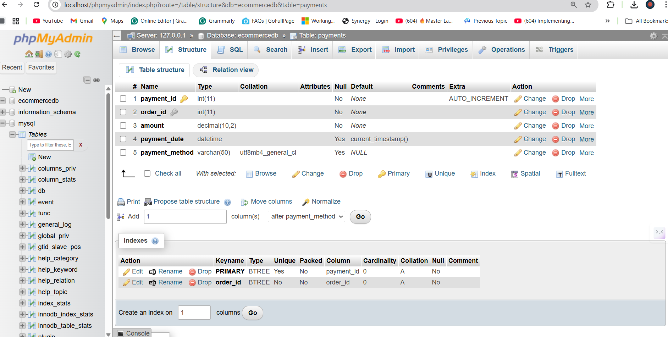

All Table

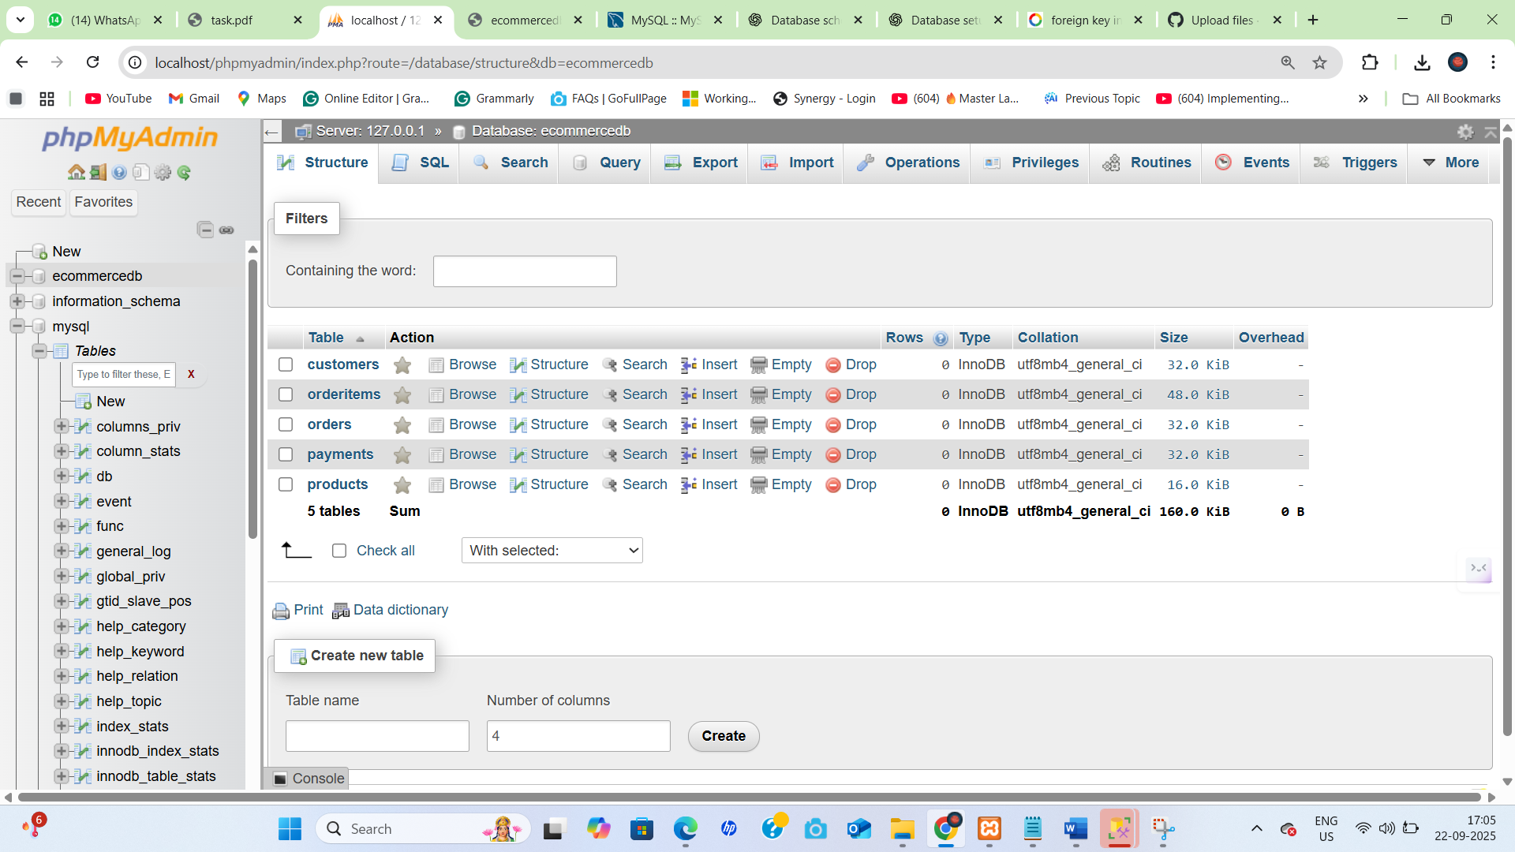

3 ER Diagram

Customers (customer_id PK)

|

|<--1:N

Orders (order_id PK, customer_id FK)

|

|<--1:N

OrderItems (order_item_id PK, order_id FK, product_id FK)

^

|

Products (product_id PK)

|

|<--1:N

Payments (payment_id PK, order_id FK)

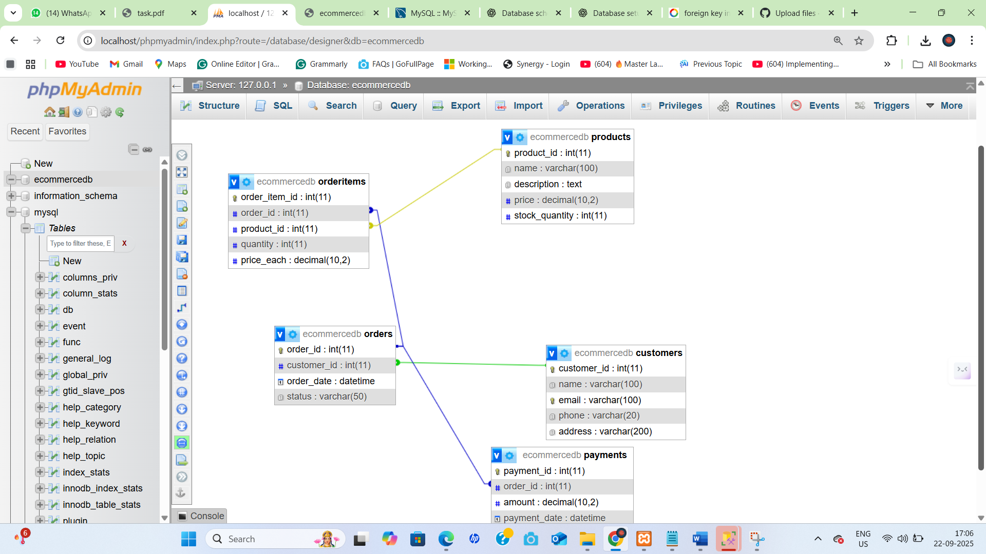

Sql server Database and Table Creation

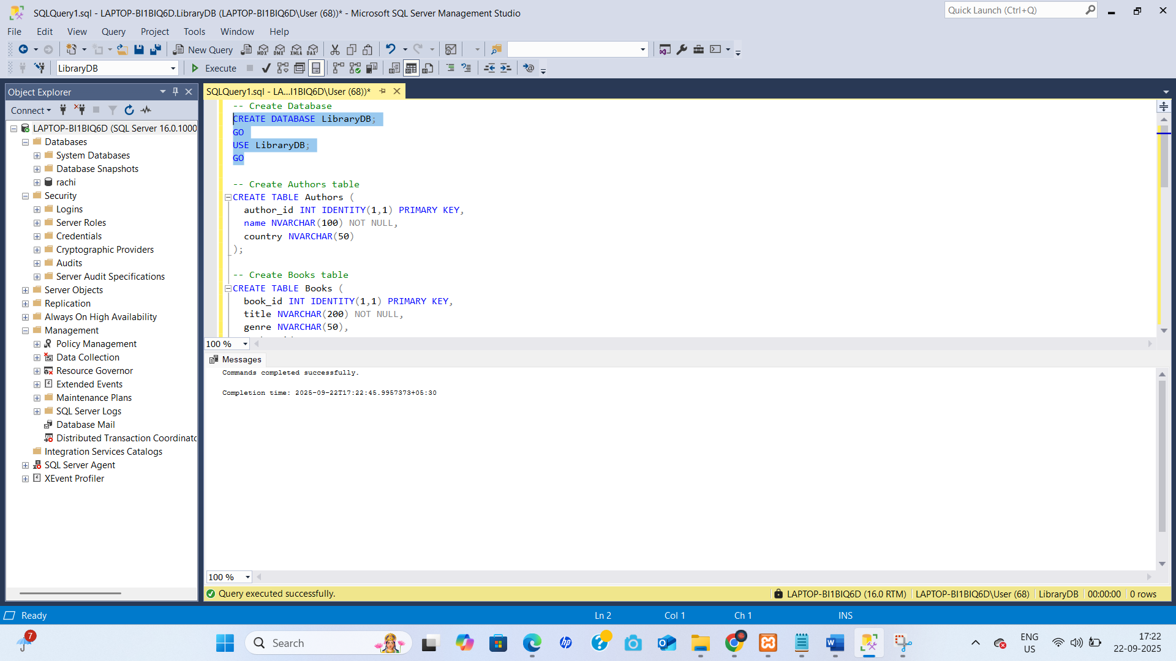

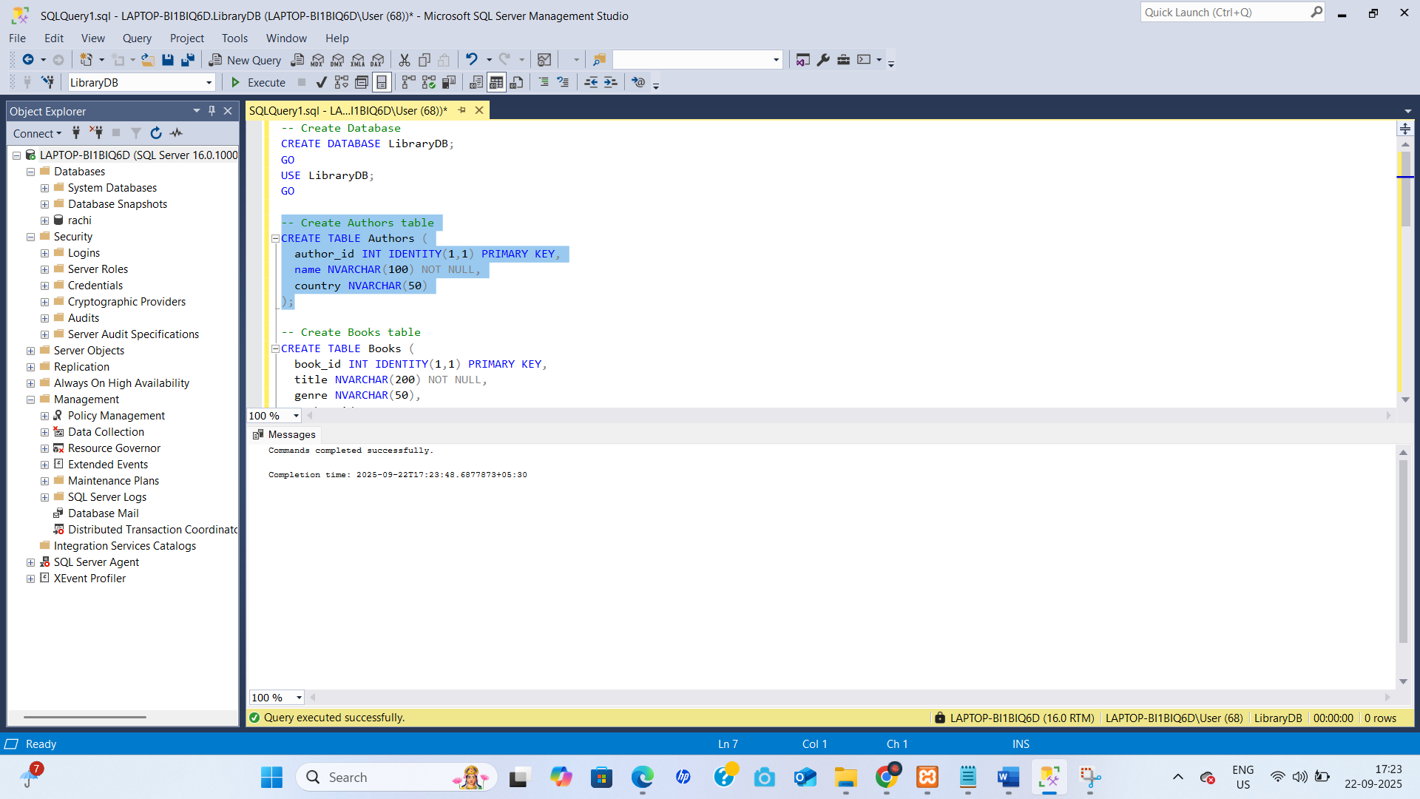

All Table

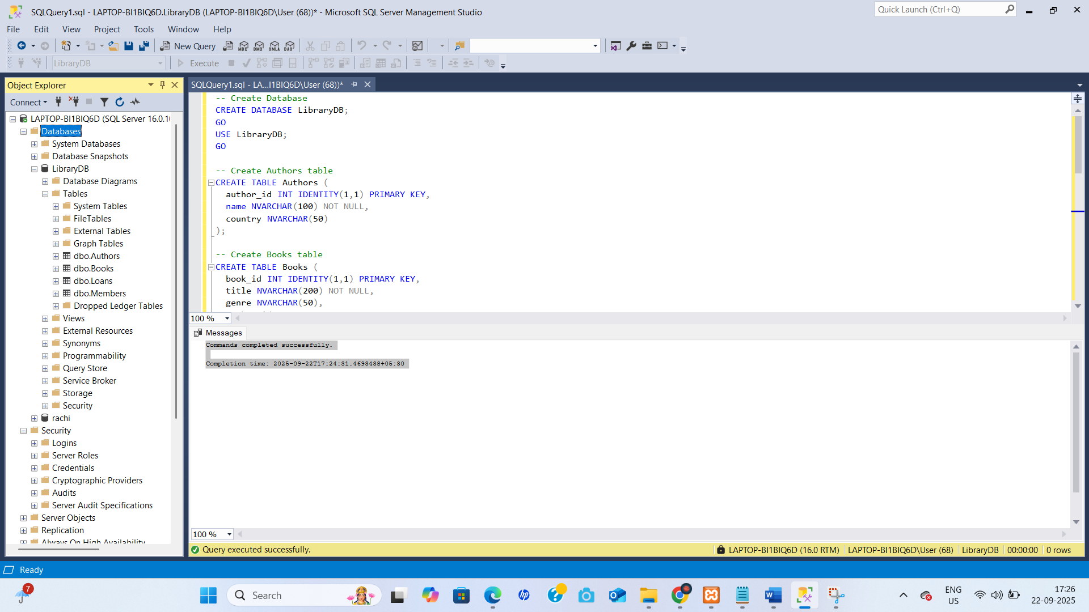

Schema -Diagram

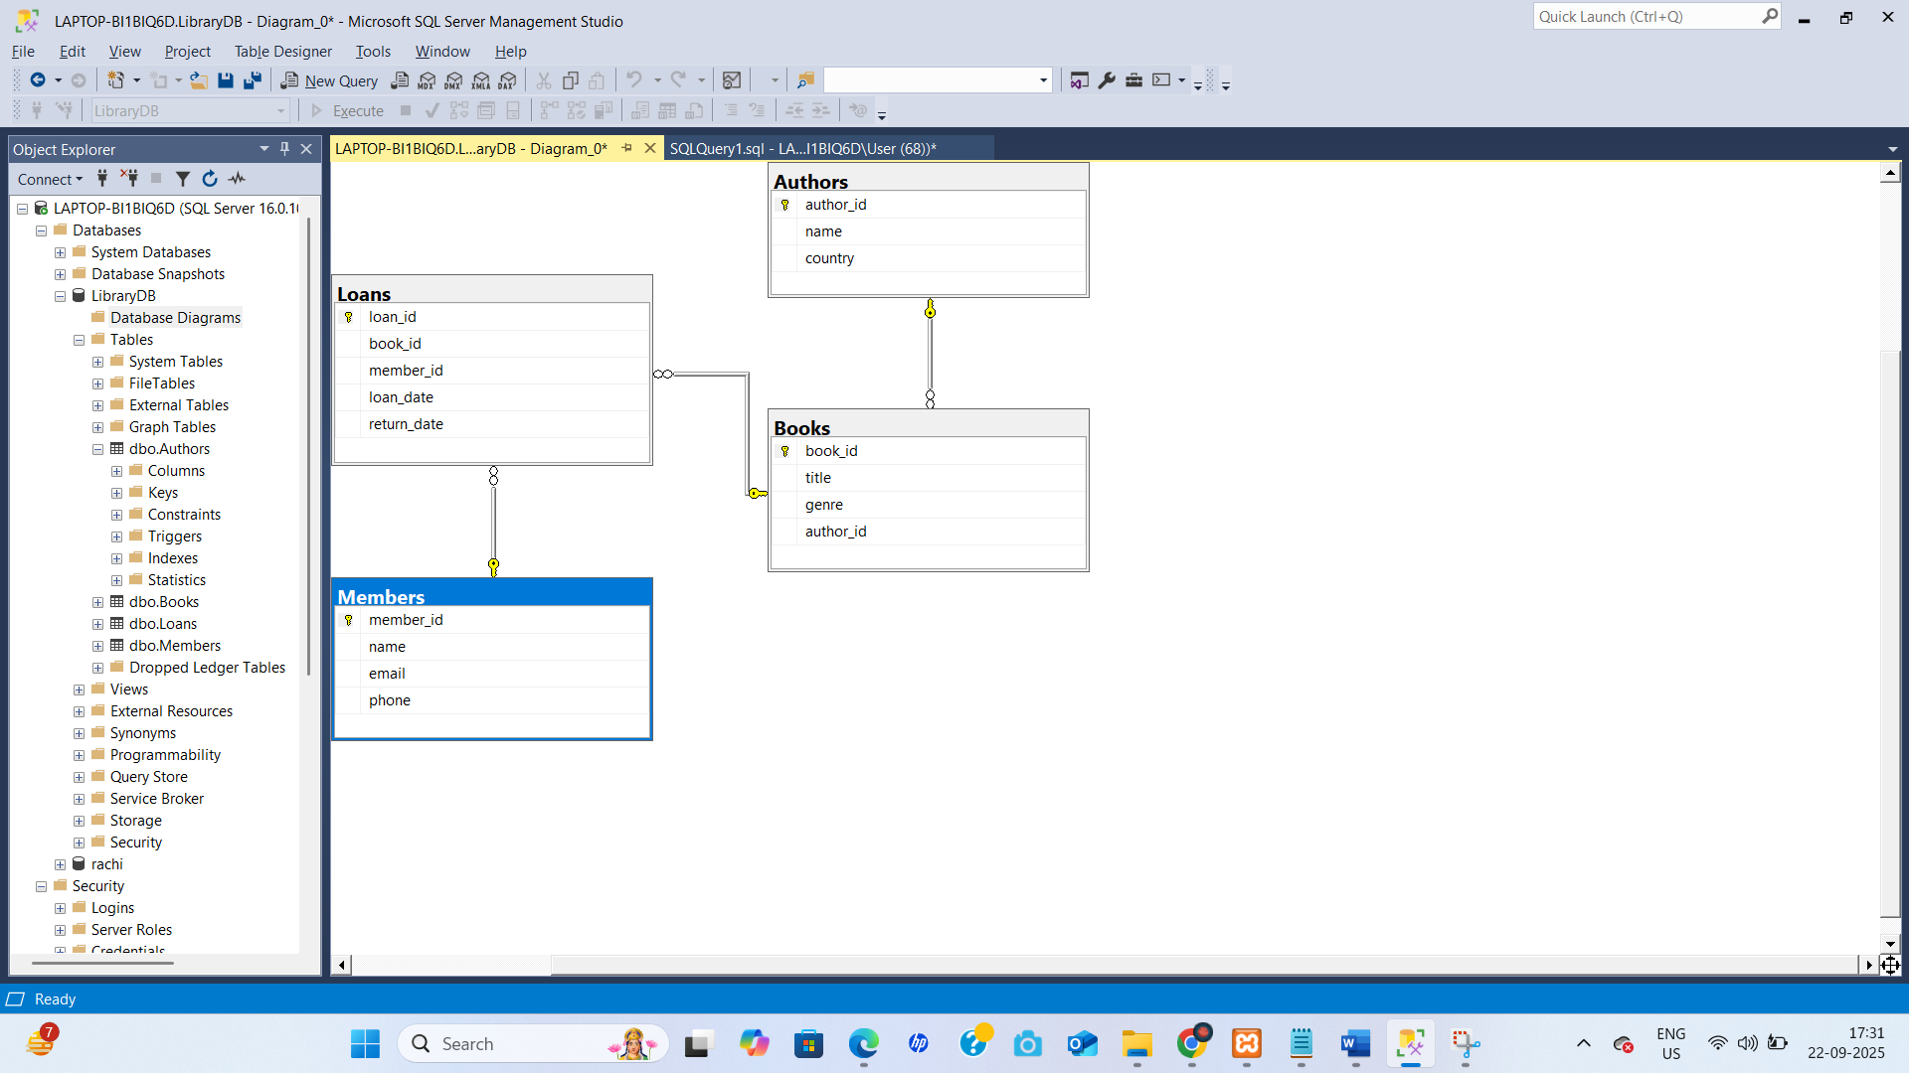

**Interview Questions & Answers**

1. **What is normalization?**
   * The process of organizing database tables to **reduce redundancy** and **improve data integrity**.
   * Example: Storing customer info in a separate table instead of repeating it in every order.
2. **Explain primary vs foreign key.**
   * **Primary Key (PK):** Uniquely identifies each row in a table.
   * **Foreign Key (FK):** A column that references a primary key in another table to establish a relationship.
3. **What are constraints?**
   * Rules applied to table columns to ensure data validity.
   * Examples: NOT NULL, UNIQUE, CHECK, PRIMARY KEY, FOREIGN KEY.
4. **What is a surrogate key?**
   * A system-generated unique identifier (usually numeric) used as a primary key instead of using natural data.
   * Example: customer_id INT AUTO_INCREMENT.
5. **How do you avoid data redundancy?**
   * By **normalizing** data into multiple related tables and using keys to connect them.
6. **What is an ER diagram?**
   * **Entity-Relationship diagram:** Visual representation of entities (tables), their attributes, and relationships (1:1, 1:N, M:N) in a database.
7. **What are the types of relationships in DBMS?**
   * **One-to-One (1:1):** One record in Table A matches one in Table B.
   * **One-to-Many (1:N):** One record in Table A matches many in Table B.
   * **Many-to-Many (M:N):** Many records in Table A match many in Table B (handled via a junction table).
8. **Explain the purpose of AUTO_INCREMENT.**
   * Automatically generates a **unique number** for a primary key when a new row is inserted.
9. **What is the default storage engine in MySQL?**
   * **InnoDB** — supports transactions, foreign keys, and row-level locking.
10. **What is a composite key?**
    * A primary key made of **two or more columns** to uniquely identify a record.

**Key Concepts**

* **DDL (Data Definition Language):** Commands used to define or modify database structures.
  + Examples: CREATE TABLE, ALTER TABLE, DROP TABLE.
* **Normalization:** Process to organize data into tables, reducing duplication and dependency.
* **ER Diagrams:** Visual representation showing **tables (entities), attributes, and relationships**.